Installing and configuring Docker on Amazon Linux EC2 instance.

Synopsis:

1.Demonstrate how to Install and configure Docker on Amazon Linux EC2 instance in US region (Default VPC, Default Storage, All traffic allowed from anywhere).

2.Check the docker components by running docker info command

**Steps for question 1**

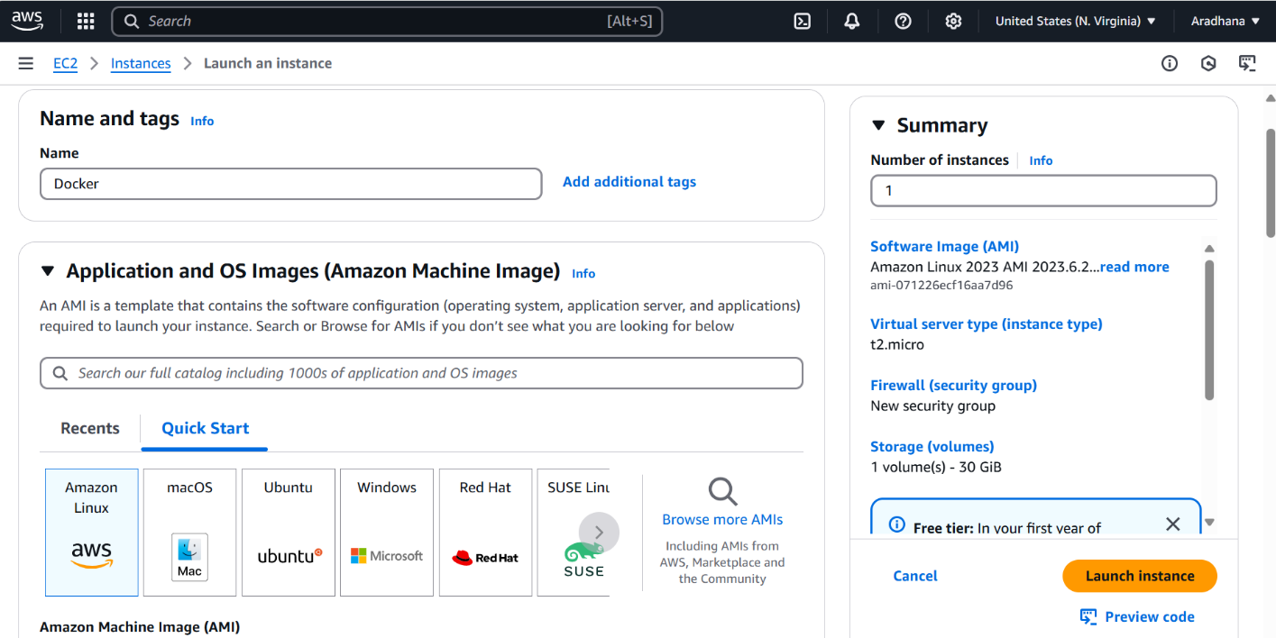

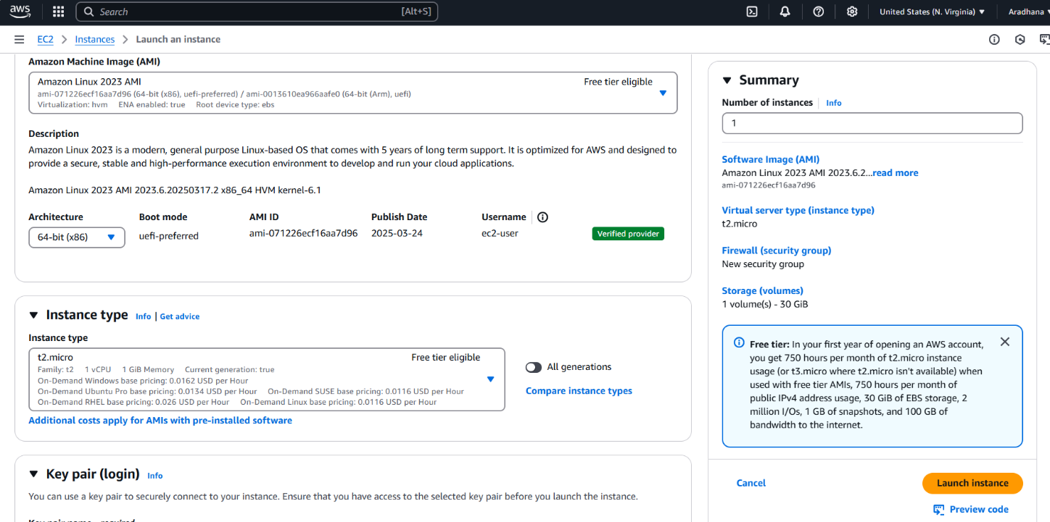

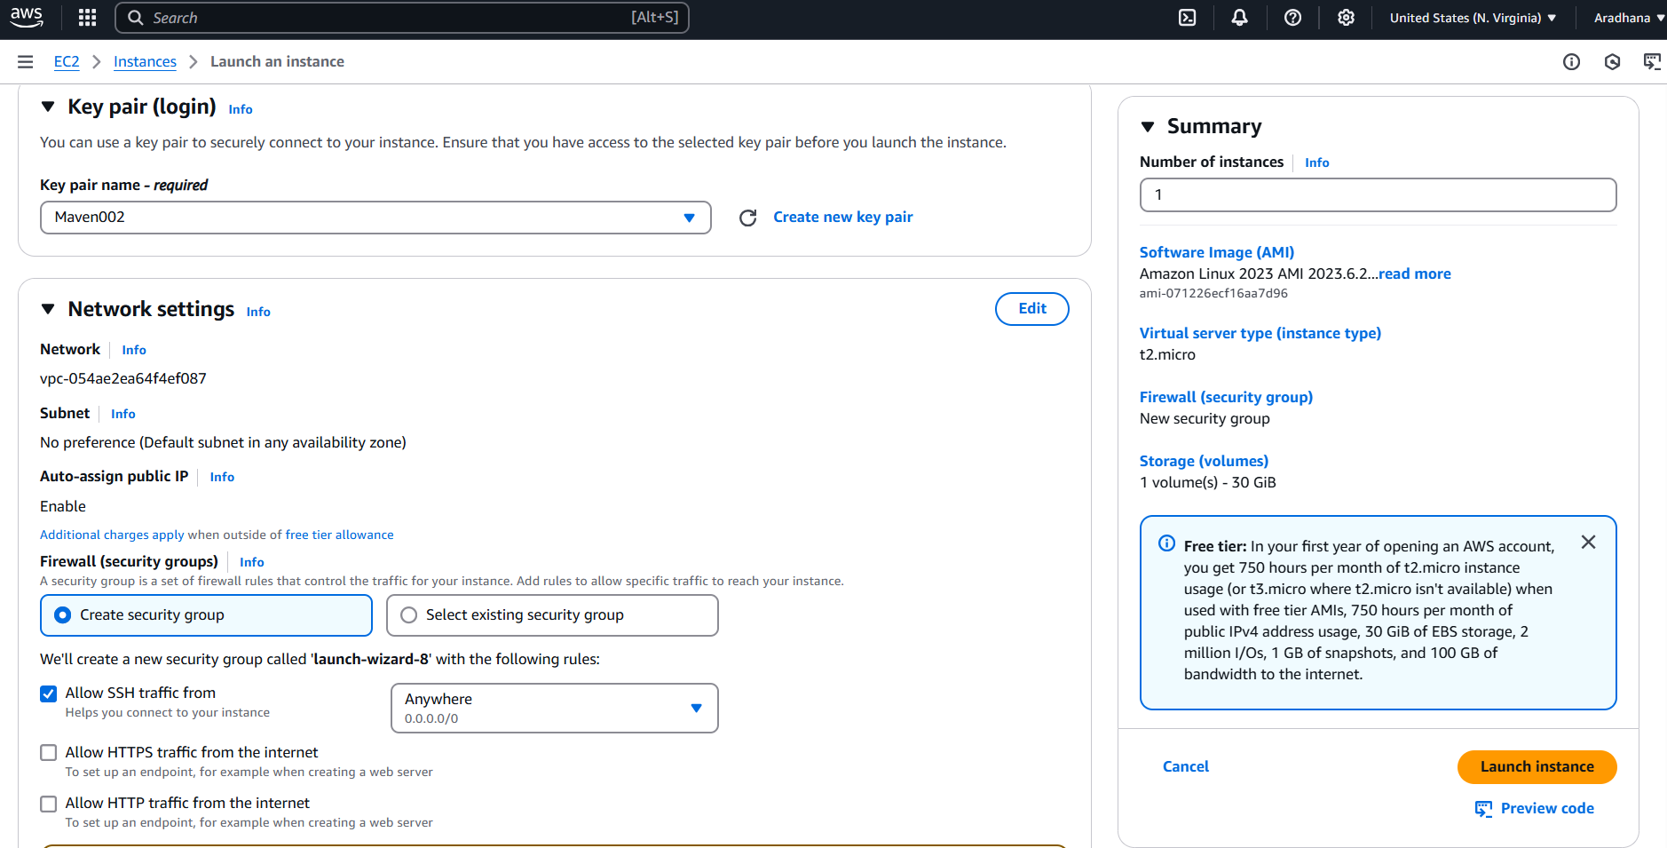

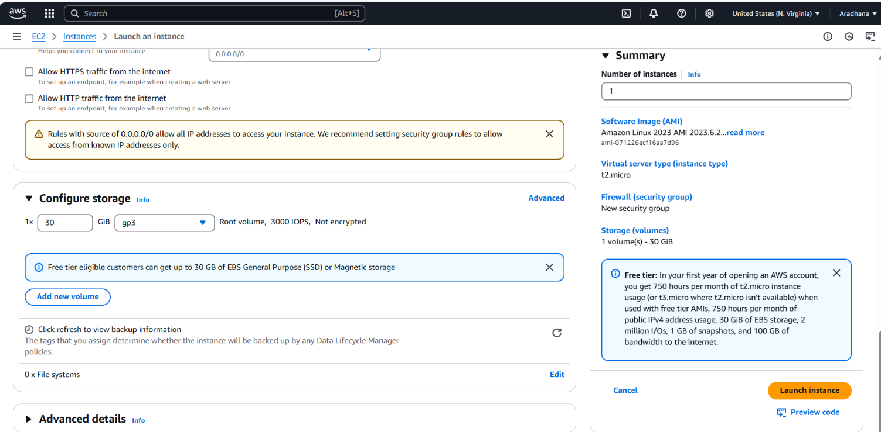

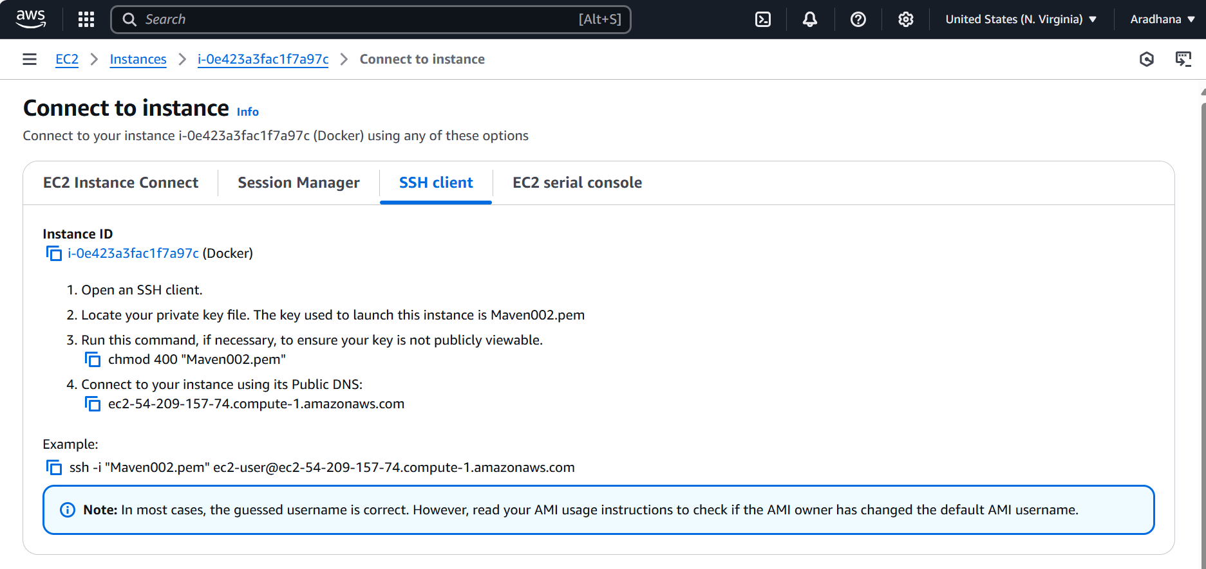

**Steps of question-2**

